Algal community response to pollution and environmental change in Lake Baikal, Russia, over the last 1000 years

Three year NERC-funded studentship (starts September 2012)

Supervisors: Suzanne McGowan (University of Nottingham), George Swann (University of Nottingham) & Anson Mackay (University College London)

Background
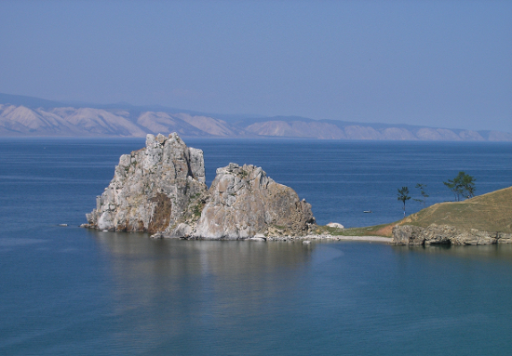
Lake Baikal is the world's oldest lake lying in a rift zone in south eastern Siberia (103º43'-109º58'E and 51º28'-55º47'N) that began to form over 20 million years ago. As well as being the world's deepest and most voluminous, the lake also acts as a major water resource containing c. 20% of global surface freshwater. A key feature of Lake Baikal is the high degree of biodiversity with over 2,500 flora and fauna, the majority of which are endemic. Such high levels of endemicity have led to the lake being cited as the "most outstanding example of a freshwater ecosystem" and resulted in the site being designated a World Heritage Site in 1996. Industrial development and changes in catchment land-use since the 1950's, however, pose real and serious threats to the stability of the lake's ecosystem with pollution entering the lake from major conurbations, industrial centres, mining and agricultural practises. The lake is also responding strongly to anthropogenic climate change. Firstly, global warming is having a major impact on regional permafrost with increased melting leading to enhanced nutrient inputs to the lake. Secondly, marked increases in water column temperatures have been observed in the south basin. Thirdly, the duration of ice cover and ice thickness have declined significantly in recent decades with further declines forecast for the future. Such changes will have major implications for the food-web interactions and the wider ecosystem from the rapid growth of primary producers underneath clear ice to the lake's top consumer, Phoco sibirica (the world's only freshwater seal). In order to ensure that future development and policy plans for the catchment are capable of sustaining Lake Baikal's unique ecosystem, there is a need for a detailed understanding as to the impact of anthropogenic influences on the lake.

Project
This NERC-funded PhD studentship forms parts of a larger NERC Standard Grant award examining “Silicon isotope records of recent environmental change and anthropogenic pollution from Lake Baikal, Siberia” which aims to examine: 1) the impact of recent 20th Century catchment development and climate change on nutrient utilisation; 2) ascertain the response of the lake to natural climatic changes that have occurred over the last 1000 years. The studentship will complement this work by specifically examining the response of non-siliceous algal groups in Lake Baikal to both natural and anthropogenic changes over these intervals using chlorophyll and carotenoid pigment biomarkers. In the first instance the student will investigate the contemporary algal pigments, the taxonomic composition of the phytoplankton and their link to environmental conditions to elucidate the factors driving the phytoplankton community composition. The student will then investigate the sedimentary pigment record on a number of cores spread throughout the lake that are both distal and proximal to sources of pollution to 1) reconstruct changes in non-siliceous algal groups over the past 1000 years; 2) understand how non-siliceous algal communities respond to environmental changes in polluted and relatively pristine areas of Lake Baikal. The project includes both winter and summer fieldwork trips to the lake as well as attendance at a number of national and international conferences to present the findings of their research.

Training
This studentship will be based at the School of Geography, University of Nottingham, ranked 6th nationally by Research Power in the 2008 Research Assessment Exercise. Within the School, the Environmental Reconstruction Research Group (a sub-theme of the Geosciences research cluster) will provide a supportive and stimulating environment for the studentship. The School of Geography has a full range of facilities for palaeolimnological work including an Environmental Change laboratory with sediment coring equipment, facilities for the geochemical analysis of sediments including a high-performance liquid chromatography (HPLC) laboratory for analysis of pigments and a palaeoecological suite with a range of research-grade microscopes. The student will be trained in pigment analysis using HPLC and in techniques of phytoplankton analysis, sediment coring, logging and processing. Further training in diatom analysis and the construction of ²¹⁰Pb chronologies will be provided by Anson Mackay (UCL). Generic training provided by the University Graduate School programme will be complemented by specialist courses offered by the Midlands Consortium for Postgraduate Training.

Requirements and Award
Candidates must hold a first or upper second class degree in an appropriate scientific subject and have interests in the areas of aquatic ecology, freshwater biology, palaeolimnology and palaeoclimatology. Previous geochemical experience is an advantage but not essential. Due to NERC requirements, this award is only available to UK citizens or candidates who meet the eligibility set out in the NERC Studentship Handbook. This studentship is fully funded by NERC and covers all fees, an annual maintenance award of £13,590 per annum (2012/13 level) over 3 years as well as all fieldwork, conference and laboratory costs. The successful applicant must be available to start the studentship at the end of September 2012.

How to apply
Application forms are available here or from Andrea Payne (andrea.payne@nottingham.ac.uk), Postgraduate Administrator, School of Geography, University of Nottingham, University Park, Nottingham, NG7 2RD. Tel: 0115 951 5575.

Enquiries specifically related to the project should be sent to either Suzanne McGowan (suzanne.mcgowan@nottingham.ac.uk) or George Swann (george.swann@nottingham.ac.uk).

Closing date for applications: 31 March 2012.

